Catapults

| **Subject:** Physics  **Related Subjects:** Mechanical Engineering | **Grade Level(s):** 3-8 th  **Length of Lesson:** 55 mins | **Type:** Project  **Keywords:** Catapult, Lever, Fulcrum, projectile |
| --- | --- | --- |

# Lesson Overview

*Students will participate in the engineering design process by creating a prototype, investigating a problem, and testing their catapults.*

# Lesson Focus

# *What is a fulcrum and a lever? What is a constraint?*

| Lesson Objective(s) | By the end of this lesson, students will…   1. Understand fundamentals behind catapults (lever, fulcrum, etc.) 2. Describe how force affects the motion of a projectile |
| --- | --- |

# Lesson Timing

| 15 minutes | Introduction/Lesson on Catapults |
| --- | --- |
| 15 minutes | Design and Build |
| 10 minutes | Testing the Catapult |
| 10 minutes | Present/discussion |
| 5 minutes | Wrap Up |

| Materials | * 3 sheets of paper * 1 spoon * 3 pencils * 2 cups of the same height (plastic, paper, etc.) * 5-7 Rubber bands * Tape * Scissors * * = per student/group |
| --- | --- |
| Teacher Prep | 1. Practice the lesson 2. Watch the video below for reference but don’t show students |
| Related Resources | * [Catapult Ball Launch](https://www.youtube.com/watch?v=FMcbAiTfx7A&t=2s) |

# Lesson Plan

## Introduction

1. Ask the students:
   1. Does anyone know what a catapult is?
      1. A catapult is a simple machine that can launch or throw an object. As you can see in the photos, there are many types of catapults made of different kinds of materials.
   2. Does anyone know what catapults were used for in the past?
      1. Originally catapults were designed for use during battles or wars. These days, catapults are used for a variety of reasons, from toys to even launching planes and jets from aircraft carriers that have limited runway space! Has anyone ever seen or used a sling-shot before? Well guess what? That is an example of a simple catapult!
2. Show students the video: [ADLC - Elementary Science: Trebuchets and Catapults](https://youtu.be/egZhg7v4NRs)
   1. Stop at 3:47

## Lesson on Catapult Parts

1. In the video, we learned about levers and fulcrums. Can anyone see where the lever and fulcrum is in each of these photos? Have students point out/describe:
2. Now, should the fulcrum be at the center of the lever? For someone who said no, can you tell me a little bit more about why you said no?
3. So what you all will be doing today is building your very own catapult!
4. Here are some homemade catapults that are easy just to show you some examples. 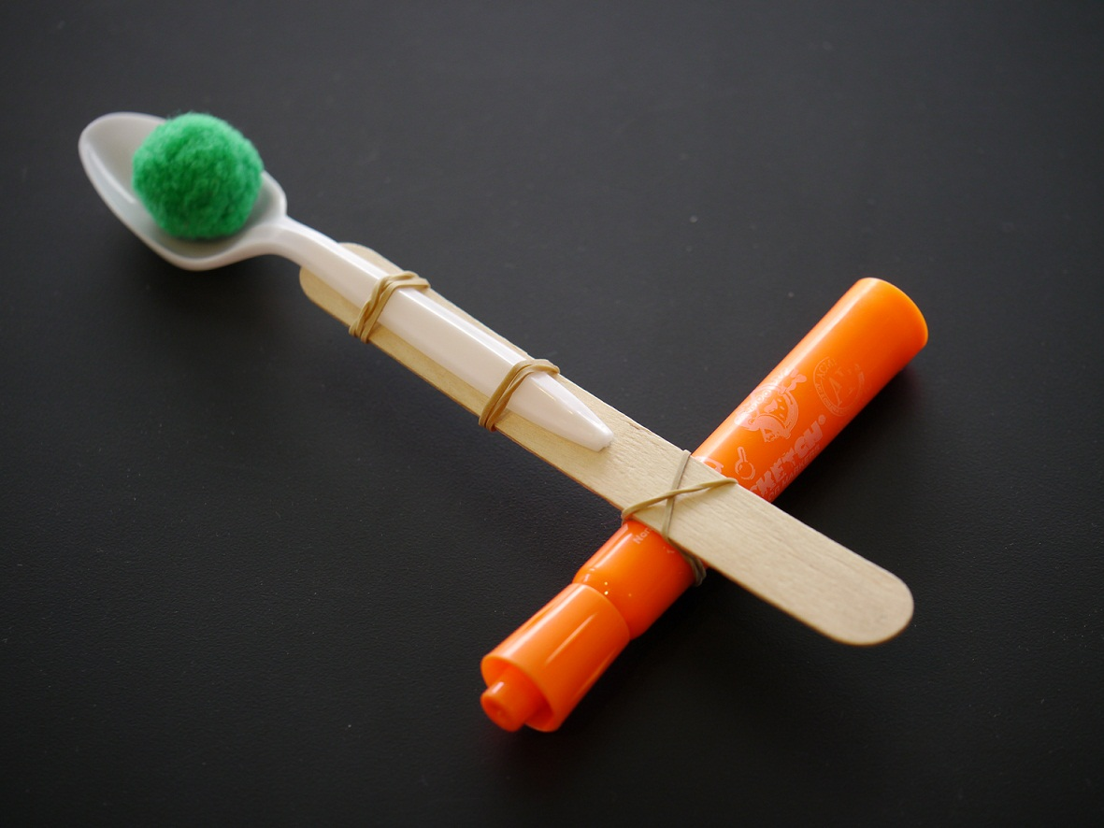

## 

## Design & Build

1. Recap Engineering design process
   1. 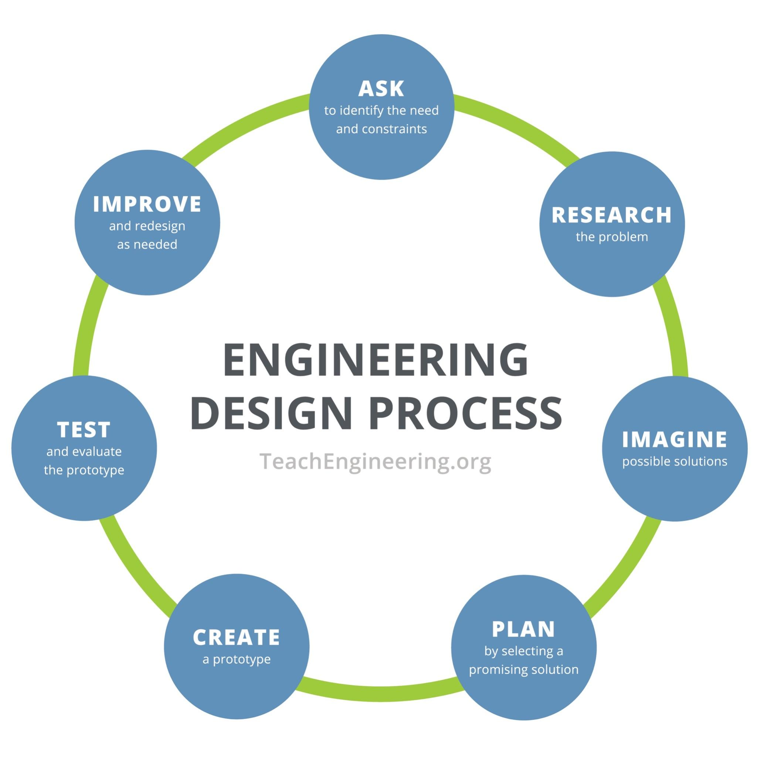
2. When designing anything, we have to think about our constraints. Does anyone know what the word constraints means?
   1. Something that limits us from being able to do something.
3. When we build our catapult what limitations do we have?
   1. Time, limited resources/materials, money
4. **Imagine/Plan:** Give the students 5 minutes to draw their designs.
5. After showing their drawings to the class, the students will have 10 minutes to **Create** their catapult.
6. Allow the students to show their catapults. Ask a few students to share how they came up with their catapult prototype.
7. Now that you have built your catapult it’s time to **test** out how well it works and then try to **improve** your first design by making 1 small change (which is the final step of the engineer design process. Here is your challenge:
   1. Test out the type of materials used as a lever (wooden spoon, metal spoon, plastic spoon, straws, ruler, etc) to see which one would be best to launch the paper ball into a cup or a target (draw a target on a piece of paper)
8. You will do 3 trials with at least 2 different designs (i.e one with a metal spoon and one with a ruler) Be sure to record the distance travelled in feet. (If you have time for a third, go for it! *Be sure to record your measurements!*
9. If you have time, think about what might happen if you change the height (use smaller or larger cups) Try it out and see what happens.
   1. *\*Please note- use a crumpled up piece of paper as your “ball” to launch. You may need to use half a piece of paper to make a smaller ballet to fit in your spoon*
10. You will have 10 minutes to complete this and then we will talk about our results!

## Present/Discussion

1. Have students briefly present their finished catapult
2. Ask students questions about their catapult:
   1. What design worked best? Least?
   2. How did changing the lever (spoon) affect how far the object traveled?
3. Results Challenge Table: What results did you get? What does that tell us about your catapult?
4. How did changing the height of the cups impact the catapult?

## Wrap-up

1. What part of your design didn’t work so well? Why or why not?
2. If there was enough time to do another prototype and you had no constraints (more materials available to you), what would you do differently?
3. Can everyone share one thing they learned today whether it be about the engineering design process, something about your catapult design, or something about simple machines/levers?

# Lesson Background for Teachers

## Middle School Variation

* Introduce the concept of accuracy vs precision
* Optimal angle of launch (45 degrees)
  + If a projectile is launched from an angle greater than 45º, where will it go? (Answer: It will go higher, but not cover as much horizontal distance.) If the same projectile is launched from an angle less than 45º, where will it go? (Answer: It will not go as high and therefore is pulled to the ground more quickly by gravitational force, and thus, falls short.)

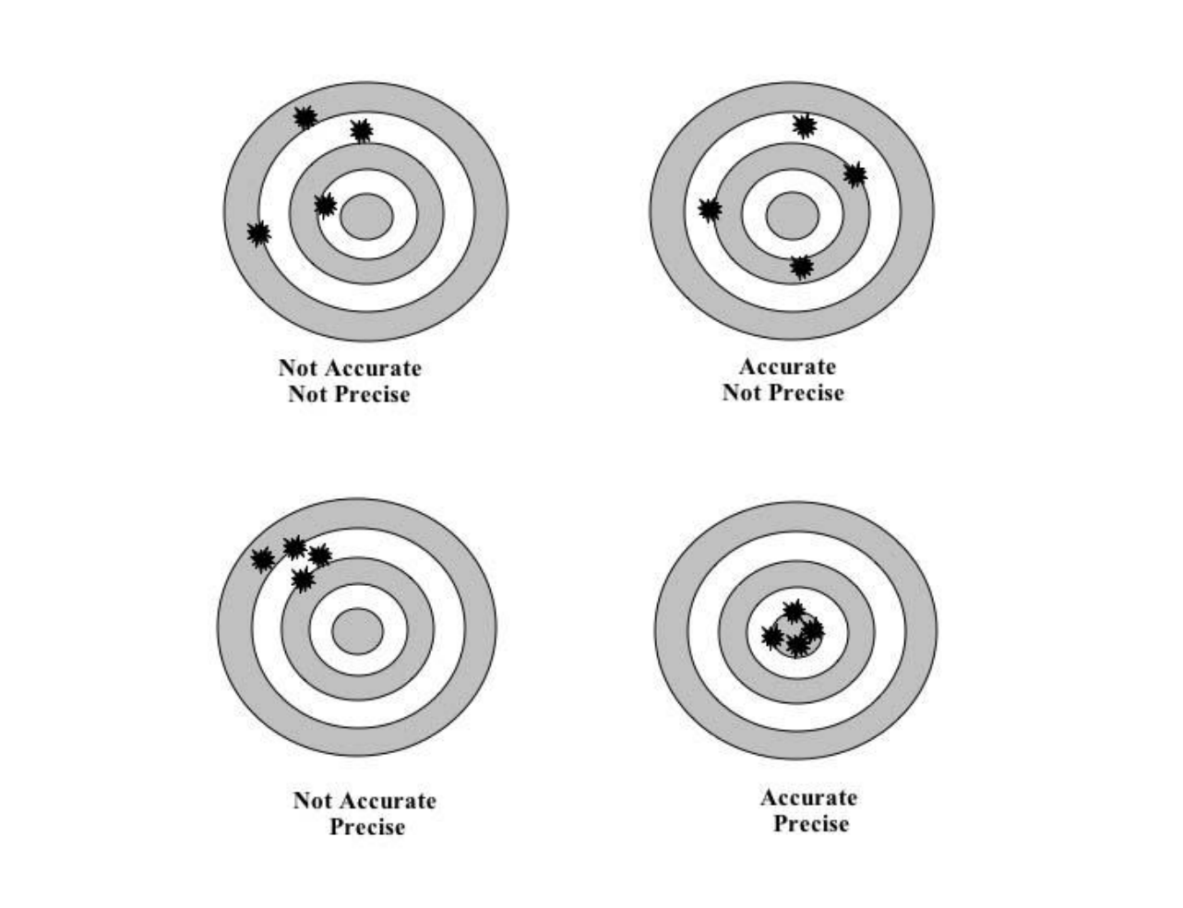

* Students can create a target and mark where their projectile lands and evaluate the level of accuracy and precision of their catapult (accuracy --- hitting the center, precision -- hitting the same spot)

## Key Concepts and Vocabulary

* **Catapult:** A simple machine that can launch or throw an object.
* **Fulcrum:** The amount of matter in an object
* **Lever:** How much space something takes up
* **Constraint:** Something that limits us from being able to do something